**National University of Computer & Emerging Sciences, Karachi** **Fall 2023 (School of Computing)   
Assignment # 1**

|  |  |  |
| --- | --- | --- |
| **Course Code:** CS-1002 | **Course Name:** Programming Fundamentals | |
| **Course Instructors:** Mr. Muhammad Shahzad, Dr. Farooque Hassan Kumbhar, Dr. Abdul Aziz, Mr. Syed Zain Ul Hassan, Mr. Basit Ali, Ms. Sobia Iftikhar | | |
| **Open Date:** September 8, 2023 | | **Deadline:** September 17, 2023 (11:55 PM) |

**Instructions:**

* You are required to add just one line of code to perform upcasting for the given generic classes.
* You'll need to add the line of code for upcasting and then submit a single .***txt*** file containing the modified code.
* Before submission, rename your file as your ID e.g., ***k20-1234.docx***
* To be submitted on **Google Classroom**

**Problem 1 (a):**

1. BEGIN:

NUMBER num1 , num2 , gcd = 1, i

PRINT "Enter first Number:"

INPUT num1

OUTPUT "Enter second Number:"

INPUT num2

FOR i = 1; i <= num1 && i <= num2; ++i

IF num1 % i == 0 && num2 % i == 0 THEN

gcd = i

END IF

END FOR

PRINT " GCD of "+ num1 +"and "+ num2 +" is "+ gcd

END

1. BEGIN:

INPUT a, b and c

sum = 0

sum = a + b

IF sum < c THEN

PRINT “Sum of a and b is greater than c”

ELSE

PRINT “Sum of a and b is not greater than c”

END IF

END

1. BEGIN:  
   INPUT N  
   NUMBER LIST of N elements

MIN = LIST[1]

FOR POS = 2 to N:

IF LIST[POS] < MIN THEN:

MIN = LIST[POS]  
 END IF  
END FOR  
PRINT “Smallest number is : “ + MIN  
END

1. BEGIN:  
   INPUT N  
   NUMBER LIST of N elements

FOR k = 1 to (n-1):

FOR j = 0 to (n-k-1):

IF LIST[j] > LIST[j+1] THEN:

temp = LIST [j];

LIST [j] = LIST [j+1];

LIST [j+1] = temp;

END IF

END FOR

END FOR

END

1. BEGIN:  
   INPUT N, COUNT = 0  
   LIST of N elements  
   FOR POS = 1 to N:

IF LIST[POS] % 2 == 0 THEN:

COUNT = COUNT + 1

END IF

END FOR  
 END

**Problem 1 (b):**

1. .

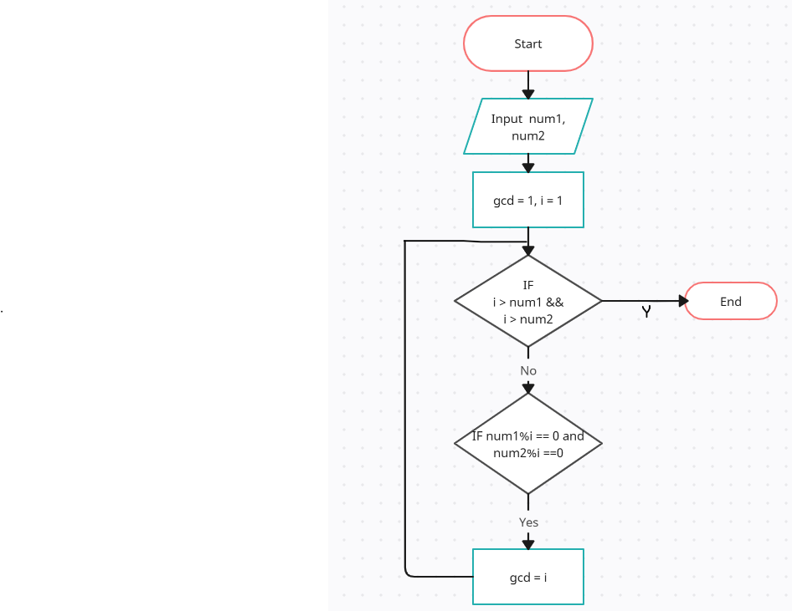

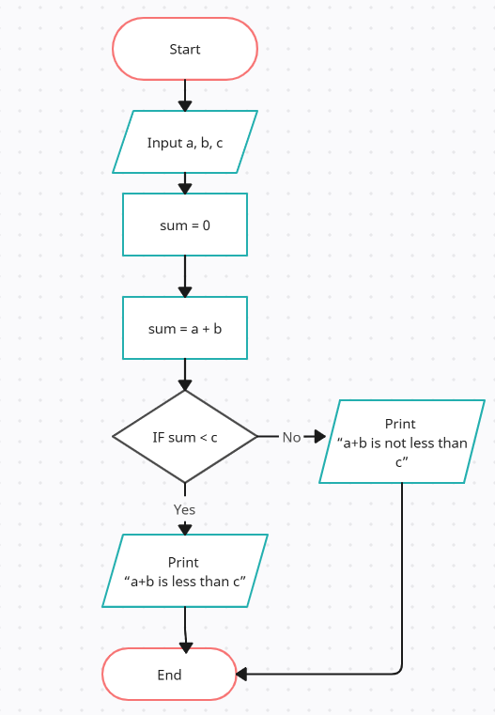

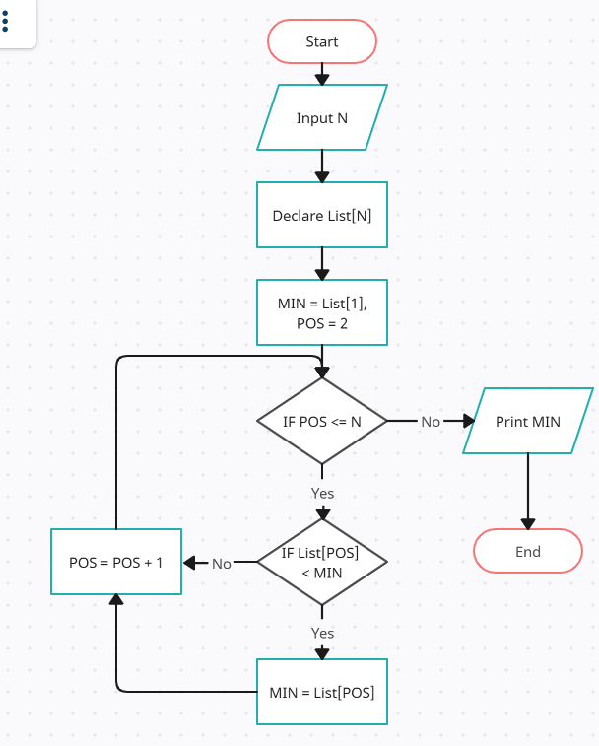

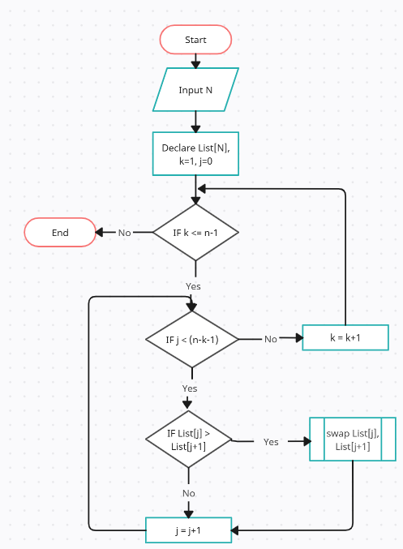

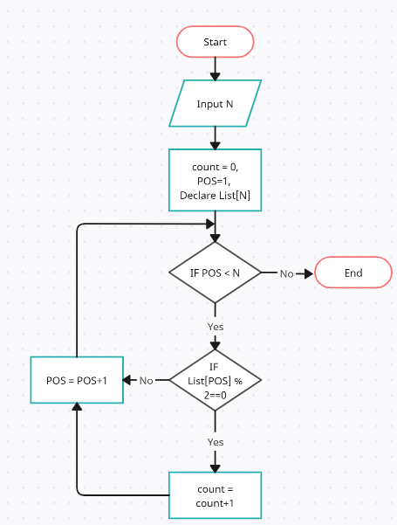

**Problem 2:**

1. Age: unsigned int
2. Temperature: int
3. Longitude: double
4. Third letter of name: char
5. Wind speed: unsigned int

**Problem 3:**

